Application for

Admission

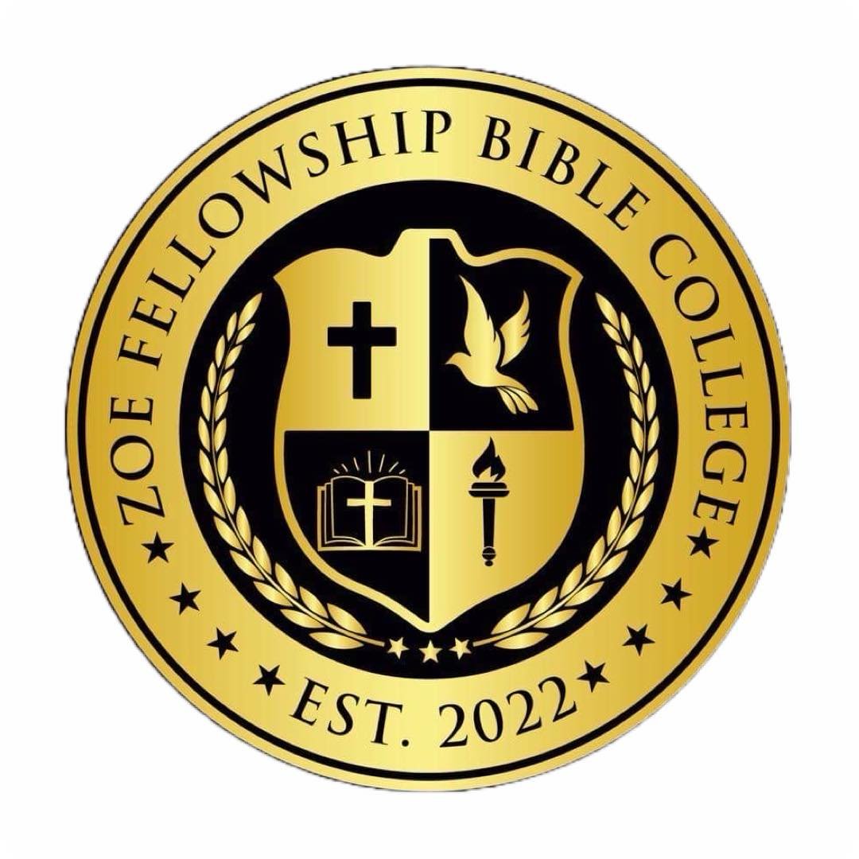

ADMISSIONS TO ZOE FELLOWSHIP BIBLE COLLEGE

Disclaimer for Collecting Information

I understand that by checking the box and submitting this application that I authorize Zoe Fellowship Bible College (ZFBC) to collect personal information about me for the purposes of applying for and participating in the ZFBC programs. I understand that this information will be used and shared with ZFBC and authorized parties that allow us to conduct programs.

Yes, I understand and give authorization

Learning Modules

Thank you for your interest in ZFBC. What learning module are you interested in:
Online / correspondence / Distant Learning
Online Virtual Classes (Meeting Once a Week: 7 pm – 9 pm)
Online / In-person classes

Basic Information
Legal First Name Middle Name

Legal Last Name Preferred Name

Date of Birth _{Month / Day / Year} _{Gender}

Email Phone Number

Marital Status Are you an U.S. citizen?

Do you currently reside in the United States?

ADDRESS INFORMATION

Zip Code

Please attach a photo of yourself to this application
Which year program are you interested in? What level of education have you completed?
Undergraduate
Associates (First Year) Associates
Bachelor’s (Second Year) Bachelor’s Degree or higher
Master’s (Third Year) Explain: _________________________
Doctorate’s (Fourth Year) _____________________________________________

Staff Use Only:
Information Verified by: _____________________ Application Status: _________________________

Placement: _________________________________

Approved By: _______________________________ Student ID #: ______________________________
“Not Just a School – But a Move”
A Move of God!
A Man’s Education is Not Complete Without
An Understanding of The Word of God!
www.zoefellowshipbiblecollege.org | 980-800-2223 | zoefellowship@aol.com

